## Contact us

20 Broad Street Glasgow G40 2QL

By phone: 0141-554 5235

[](https://www.facebook.com/venturescotland/)@RecoveryNE

[](https://www.twitter.com/venturescotland/)@recovery_east

By e-mail: nercglasgow@gmail.com

If you are interested in supporting NERC or people who attend the cafes then please come along and get involved.

## How to become a NERC volunteer

**Volunteering Criteria**The criteria for being a volunteer within NERC is:-   
  
if in recovery from substance misuse; all registered volunteers and committee members must have a period of 90 days free from illicit drug use and problematic alcohol use  
  
4be a carer or family members affected by addiction;  
have an interest in volunteering within the North East area.   
  
**Volunteering Process   
Participate:** in NERC recovery initiatives for 4 weeks to demonstrate interest, commitment and stability  
 **Application:** to be completed and submitted to NERC and supply two references  
 **Interview:** Applicants will take part in an informal interview conducted by two NERC volunteers.  
 **PVG:** an application for each volunteer made to join the Protection of Vulnerable Groups (PVG) Scheme  
 **Training:** successful applicants will attend a 2 day mandatory induction training whilst volunteering  
  
**Development & Support** volunteers will receive support from their peers and supervision from Link Workers

COME AND

JOIN US

**“Together We Recover”**

**Why become a NERC volunteer?**

**Benefits of Volunteering**Our volunteers tell us that there are many benefits to volunteering and that they have experienced the following:-

* Increase self-confidence
* Increase self-esteem
* Help prevent isolation
* Training / Education
* Encourage responsibility
* Build resilience
* Sense of belonging
* Peer Support
* Show commitment
* Achieve a wider network
* Build your CV
* Skills for employment
* Social outings
* Good Timekeeping
* Feel part of a team
* Grow friendships
* Enhanced Personal Recovery
* A valued part of society
* Structure & reliability
* Have some fun

**Five Ways to Wellbeing** 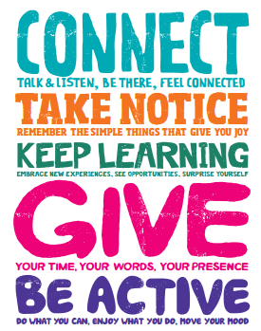

**What our volunteers say about volunteering for NERC**

Volunteering has given me a sense of purpose and achievement, I love being part of NERC team, Giving back to the community and helping others. Sharon

.

NERC has given me a new purpose in life and has allowed me to give back to my community. William

**If you have been thinking about volunteering, come and join the NERC team.**

Becoming a volunteer has given me growth, taught me honesty, how to be responsible, committed, reliable and gave me purpose. Gary